**Aim**

To write a Python program that allows two players to play the **Tic Tac Toe** game in the terminal, displaying the board after each move and declaring the result (win/draw).

**PYTHON CODE :**

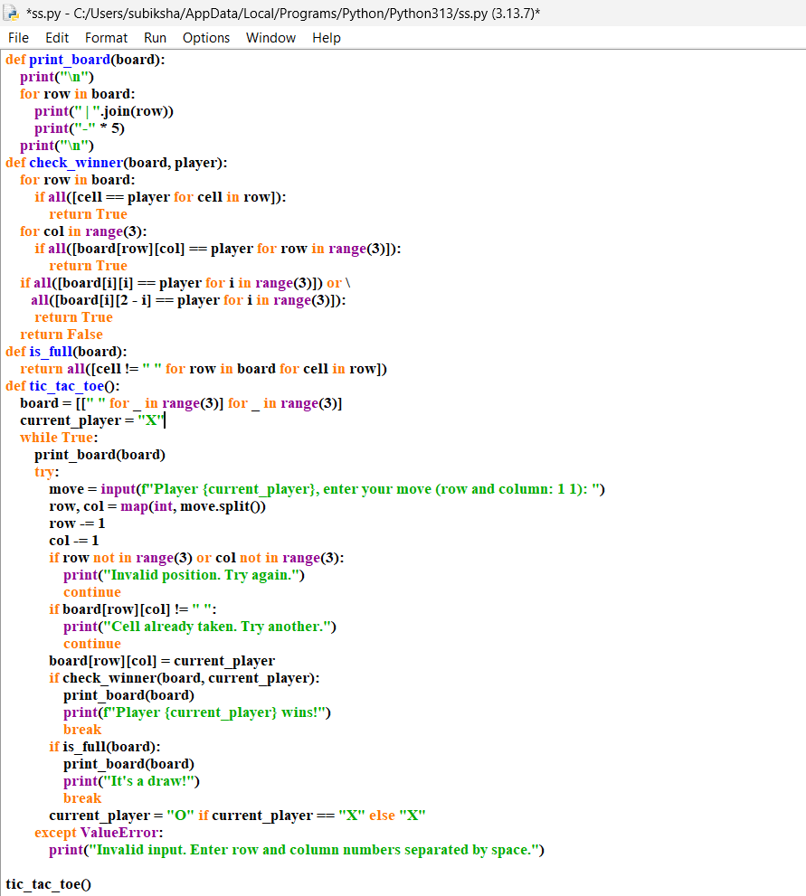

OUTPUT

